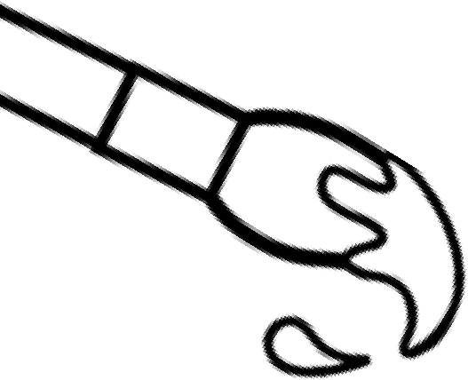
Welcome to Pottery & Sculpture
{2017-2018 Class Syllabus}
Holly Ridge Middle School

 | Mrs. Ashley Peay-Bettini • Room #303 • apeay-bettini@wcpss.net •
 | This semester course is filled with projects and activities that will boost your critical thinking habits, improve your collaborative participation, grow your creativity and develop your communication skills through writing and talking about art. We will focus our exploration of the art world through the study of the Elements of Art and Principles of Design as well as Art History and working with 3-D design.
In this class you will…  - Develop art techniques – drawing, additive & subtractive sculpture, assemblage and painting.  - Develop skills through observation and practice  It is important that you…  - Are present, prepared and on-time for class  - Are hardworking and make the most of class time  - Are honest and take responsibility for mistakes and messes  - Are safe with materials and do not waste them  - Are respectful of the classroom, the teacher’s belongings and artwork & belongings of your classmates  - Refrain from using inappropriate subject matter in your artwork  - Are responsible with the use of electronics (personal and classroom) Technology will be used as a resource in class and for photographing artwork. ONLY with teacher permission.  - Refrain from eating or drinking in class. |  | Materials needed daily:  - A pencil (not mechanical!!)  - Your Sketchbook  - Growth mindset
Grading:
All works of art will be photographed and turned in through your Artsonia account. If it is not photographed then it will be counted as a 0.
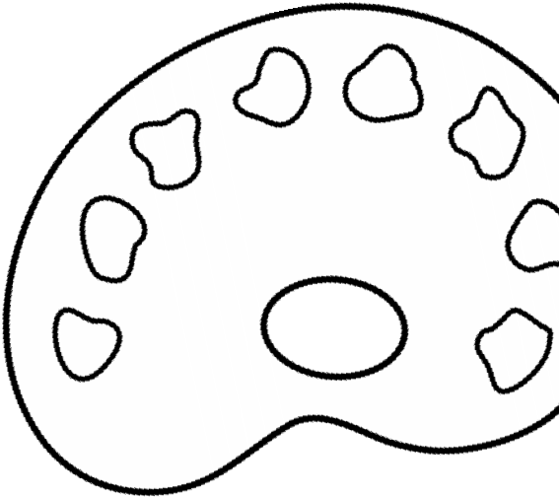
You will also participate in self-assessments and peer assessments.

Grades are weighted as follows:

10% Homework
25% Classwork and quizzes
65% Major Class projects and tests

NOTE: Sketchbooks (every other week homework)
Are ONLY accepted ON their due date or 1 day late. Those turned in one day late will receive an 89. After one day, they cannot be turned in and will receive a 0. Sometimes you will have extra time in class. This is a good time to work on sketchbook drawings. ALWAYS have your SB with you in class.
Student expectations in the art room:
Stay Safe Take Responsibility Insist on Excellence Navigate Wisely Give Respect
Supplies that you will need  __Zippered pencil pouch or 1 large (Gallon)zip-lock bag (to store personal supplies)  ___ Spiral bound sketchbook – this does not have to be new but NO LINES on paper  ___1 skein/roll of yarn (any color)  __ Fine point black Sharpie marker(s)  __ Extra-fine point black Sharpie marker(s)  __ Vinyl eraser (white)  __ Pack of 3 glue sticks  ___ #2 Pencils (not mechanical)  ___ handheld pencil sharpener  Other supplies that are available at school, but you may wish to have your own include colored pencils, markers & scissors  Label supplies with first and last name  *Please have your supplies available  to use in class ASAP!  Remind 101 is used for important due dates or other class announcements. Please sign up to keep yourself organized and informed.  To sign up, Text: @hrmsa to 81010 |  | Course Activities:  - 3D Art techniques – Additive and Subtractive Sculpture  - The Elements of Art  - Line, Shape, Space, Value, Color, Form, Texture  - The Principles of Design  - Contrast, Emphasis, Balance, Unity, Pattern, Movement, Rhythm  - Art Criticism  - An organized system for studying a work of art; description, analysis, interpretation and judgment.  - Art History  - We will reference various artists/sculptors throughout art history  Power Schools and Website:  All grading will be posted and available through Power Schools Parents please note that art projects take several days if not weeks to create. Grades will be posted as work is completed.  Important announcements, assignments and handouts will be kept up to date on my website. Please check in and know that all homework assignments with due dates and grading rubric are posted there.  The website address is: http://hollyridgeart.weebly.com/ and can be found on the school website.  Links to Artsonia can be found here as well.  A little something about your teacher:  I grew up in North Carolina and received my Art Education degree from Meredith College in Raleigh, NC. I have a minor in Art History and also a degree in English – so, don’t be surprised when I ask you to read and write!! I teach at the N.C. Museum of Art in the summers.  I am married and have 3 sons, a dog, a cat, a bearded dragon and 7 chickens. I love to read, draw, paint, watch movies, paddle board & kayak, do puzzles, camp, travel and go to museums
(Please detach and return to Mrs. Bettini)
Pottery & Sculpture • Room #303 • apeay-bettini@wcpss.net •
I have read the Art Room Expectations and gone over them with a parent/quardian and understand what is expected of me. I will abide by these expectations.
Name – (please print)___________________________________________period_____________
Signature___________________________________________
Parent/Guardian Name________________________________best way to be reached_____________
Signature__________________________________________ parent phone_____________________

